1. **INTRODUCTION**

Urbanization happens at a fast pace worldwide therefore metropolitan cities find protecting their air quality an absolute necessity. The heavily populated New York City confronts numerous air pollution problems that negatively affect both environmental conditions and community wellness. NYC air quality changes throughout time and geography will be analyzed through a dimensional data warehouse as the primary focus of this project.

The research aims to merge EPA and NYC Open Data sophisticated information into one interlinked system that enables both business intelligence investigations and clear revelations. A star schema data storage system enables comprehensive monitoring of PM2.5 together with second pollutant measurements for NO₂ and O₃ and health monitoring data to assess air quality impact on human health.

The developed data warehouse system remains a tool for stakeholders such as policymakers and healthcare organizations and public users to understand pollution patterns and find vulnerable areas while generating decisions to decrease environmental and health dangers. The project runs ETL procedures to maintain data quality along with consistency across datasets while complete data is achieved through this implementation. Additionally the application uses Tableau and Neo4j visualization tools to display vital trends and insights that lead to actionable solutions through intuitive interfaces.The initiative focuses on evaluating important research which enhances city sustainability and healthcare.

**2. Business Vision and Stakeholders**

**Business Vision**

Decision makers will receive high-quality integrated air quality trend insights in New York City through the primary business vision of the project. The health of urban populations depends heavily on air pollution because it affects both sustainable environments and public welfare while impacting the quality of city life. Respiratory disease and hospitalizations together with mortality rates in NYC act as a result of multiple air pollutants consisting of PM2.5 (fine particles), NO₂ (Nitrogen Dioxide), and O₃ (Ozone).

We design this dimensional data warehouse to deal with the present data problems of separated and inconsistent datasets stemming from EPA and NYC Open Data sources. NYC-Air-Quality-Analysis…. The warehouse integrates data through location-based and time-based dimensions to obtain complete knowledge of air quality variations across different seasons, neighborhoods and years.

The project delivers sophisticated analysis tools which facilitate strategic decision support on a large scale basis. Through this project authorities together with public health organizations gain the ability to pinpoint pollution hotspots and analyze seasonal patterns and predict health impact effects while determining policy effectiveness. Stakeholders use Tableau visualization tools to explore trends interactively and the Neo4j comparative database system helps conduct in-depth relationship-focused analysis on ​NYC-Air-Quality-Analysis..

Ultimately, the vision is to drive **evidence-based urban planning**, **targeted healthcare initiatives**, and **environmental policies** aimed at improving the overall quality of life for NYC residents.

**Stakeholders**

The key stakeholders for the NYC Air Quality Analysis project are:

1. **Environmental and Local Government Organisations**

* Regional offices of the EPA and the NYC Department of Environmental Protection (DEP).
* Interest: Identifying patterns in air pollution to develop new environmental laws and track adherence.

1. **Public Health Officials and Medical Researchers**

* NYC Department of Health, local hospitals, research institutions.
* Public health campaign development and intervention strategies receive input from disease-respiratory and cardiovascular information showing air pollution associations.

1. **Urban Planners and Policy Makers**

* Urban planners, transportation officials.
* Users can develop cleaner more health-oriented urban areas through pollution pattern-based design while maximizing traffic flow and construction zones alongside industrial sites.

1. **Civil Society Organizations (CSOs) and Environmental Advocates**

* Clean air initiatives, climate action groups.
* Consumers should apply transparent data for environmental protection advocacy while raising public awareness about these issues.

1. **General Public and Residents**

* NYC citizens, vulnerable populations (children, elderly).
* The public needs trusted up-to-date air quality data which enables them to plan their outdoor time and healthcare needs.

Through integrated data insights enabled by data warehouses every stakeholder group will gain positive impacts which promote both accountability and faster policies while raising public awareness.

**3. Data Warehouse Schema Design**

**Schema Design Overview**

A data warehouse with star schema design supports efficient analytical requirements for air quality trend monitoring in New York City. The simplicity and high performance of a star schema along with its capability to organize large data efficiently made it the chosen design.A star schema design enables quick aggregation with single fact tables connected to many dimension tables thus facilitating effective work of Tableau and SSRS​​Schema​​ NYC-Air-Quality-Analysis… applications.

**Fact Table: AirQuality_Fact**

AirQuality_Fact serves as the essential fact table where measurements for air quality are stored. A single record within the table shows the observed measurements of a particular pollutant indicator or aspect from both spatial and temporal dimensions.

* **Attributes:**
* **Time_Key (FK)** – Dependent on Time Dimension
* **Location_Key (FK)** – Dependent on Location Dimension
* **Indicator_Key (FK)** – Dependent on Indicator Dimension
* **Data_Value** –Measurement of pollutant concentration or health indicator​Schema​Report AirQuality_Fact

The data table contains numerical data for PM2.5 levels as well as NO₂ concentrations and O₃ levels and hospitalization rates that are associated with air pollution.

**Dimension Tables**

All facts in the schema use three dimensional tables that deliver contextual information for their facts.

1. **Time_Dimension**

* The database system stores time-based information that includes periods, seasons and start date values.
* Example attributes: Time_Key, Time_Period, Start_Date​Report Time_Dimension.

1. **Location_Dimension**

* The database contains a table for storing geographic data along with county and local district information.
* Example attributes: Location_Key, Geo_Type_Name, Geo_Join_ID, Geo_Place_Name​Report Location_Dimension

1. **Indicator_Dimension**

* The dimension outlines what health indicators and pollutants will be measured during analysis.
* The example aspects include Indicator_Key, Indicator_ID, Name, Measure, and Measure_Info along with Indicator_Type

The dimensions are designed with complete normalization that lets users split data through different viewpoints (including time period, geographic areas and measurement types).

**Justification for Schema Choice**

The company selected the star schema instead of alternate designs including snowflake schema because:

* Logical structures based on the star schema make it highly suitable for creating reports and queries because it benefits visual analysis tools such as Tableau.
* The schema enables quick aggregation performance through a reduced need of joins.
* Users with business expertise find it easy to navigate because all dimensions in the model have straightforward links to the fact table.
* Future expansions are made easy through the star schema since business users can incorporate new dimensions or facts like socioeconomic data and weather conditions.

The specifications regarding air quality data being multidimensional, time-series-oriented, and geographically distributed make the star schema the most suitable data model for this project NYC-Air-Quality-Analysis.

**Schema Diagram**

The following schema diagram visually represents the star schema architecture developed for this project:

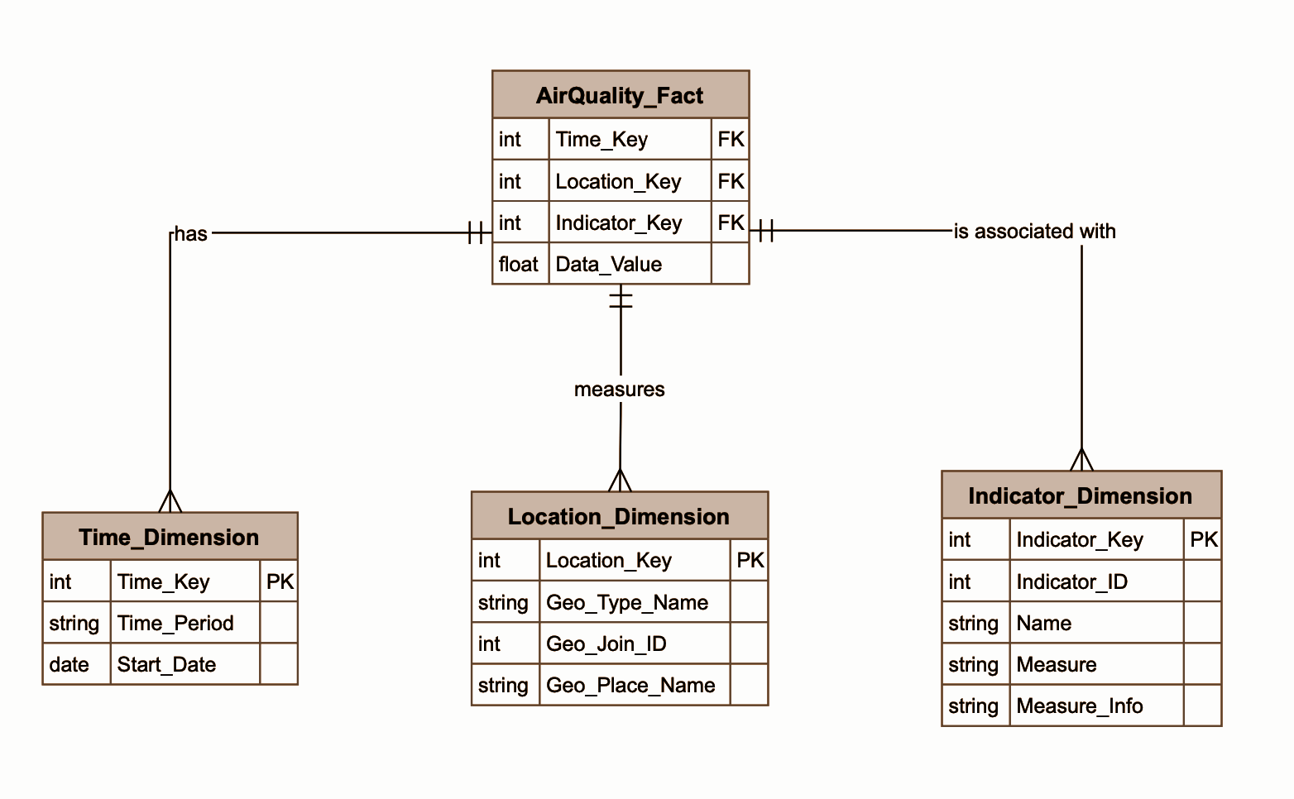

**4. ETL Process Implementation**

**Overview**

Load and transform and extract procedures formed the main foundation to prepare NYC air quality data for analytical purposes. The diverse and inconsistent nature of data obtained from EPA and NYC Open Data portals demanded an advanced ETL pipeline which extracted and cleaned and transformed required information into an analytical structure for efficient loading into the NYC-Air-Quality-Analysis dimensional data warehouse.

**Extract Phase**

Multiple sources provided the data which was extracted for the study.

* EPA Air Quality Datasets: Detailed records of pollutant measurements (PM2.5, NO₂, O₃).
* The NYC Open Data platform contains additional health-related metrics besides those found in public data.

SSIS Microsoft SQL Server Integration Services functioned first to run automated processing of raw files for extracting both structured and semi-structured data. NYC-Air-Quality-Analysis…. The extraction tasks focused on reading CSV files as well as Excel documents and database entries while maintaining metadata and data type integrity.

**Transform Phase**

The transformation phase demanded the most significant effort within ETL pipelines. Standardization and cleaning operations were conducted on the data through multiple procedures.

* For null and missing contaminant measurement values the ETL process followed business logic for imputation or removal.
* The data types across all fields underwent appropriate transformations which delivered standardized data consistency through this process.
* Standardization functions normalized textual elements in the data through a process which eradicated duplicate entries and enhanced linking between dimension keys.
* During this phase the project team established rational foreign key associations between the fact tables and dimension tables.

Record changes were developed through the use of SQL Server Data Tools (SSDT) and specific SQL scripts.

**Load Phase**

The data warehouse received the cleaned transformed information after the data delivery stage.

* **Fact Table:** AirQuality_Fact
* **Dimension Tables:** Time_Dimension, Location_Dimension, Indicator_Dimension

SSIS packages implemented control flow tasks for dependency management and transaction integrity during automated data loading operations. The system included error handling components which detected loading failures while automatically repairing issues to prevent interruptions of the whole process.

**ETL Implementation Screenshots**

The following screenshots (attached) show:

* SSIS package designer setup
* Data flow configurations
* The SSIS package makes use of transformation tasks which include Derived Column, Lookup and Data Transformation.
* Final loading processes

Visual indicators depict the entire data Moving journey starting from operational sources and finally ending with a dimensional model structure suitable for analytical purposes.

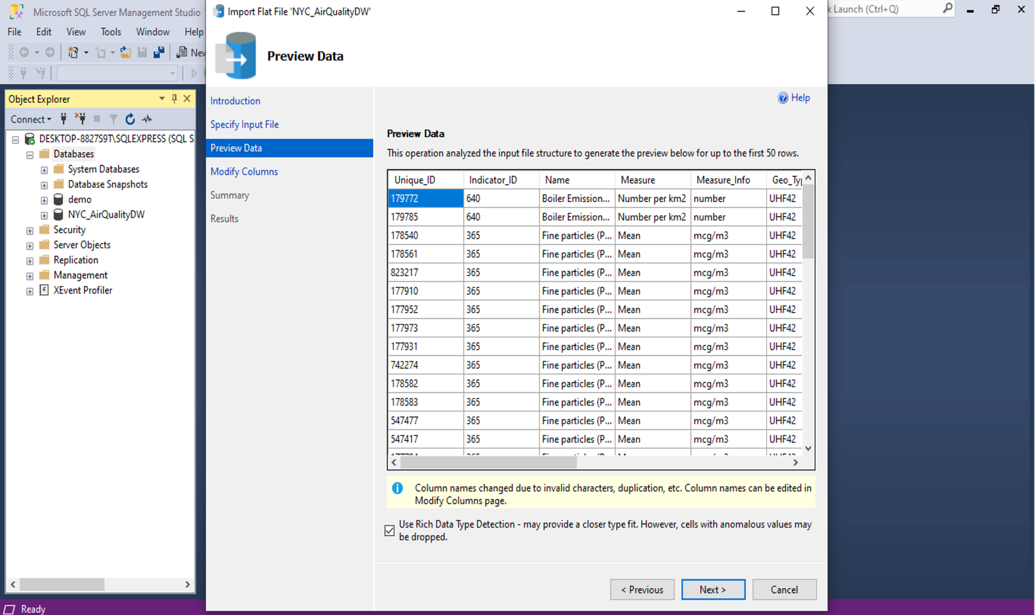

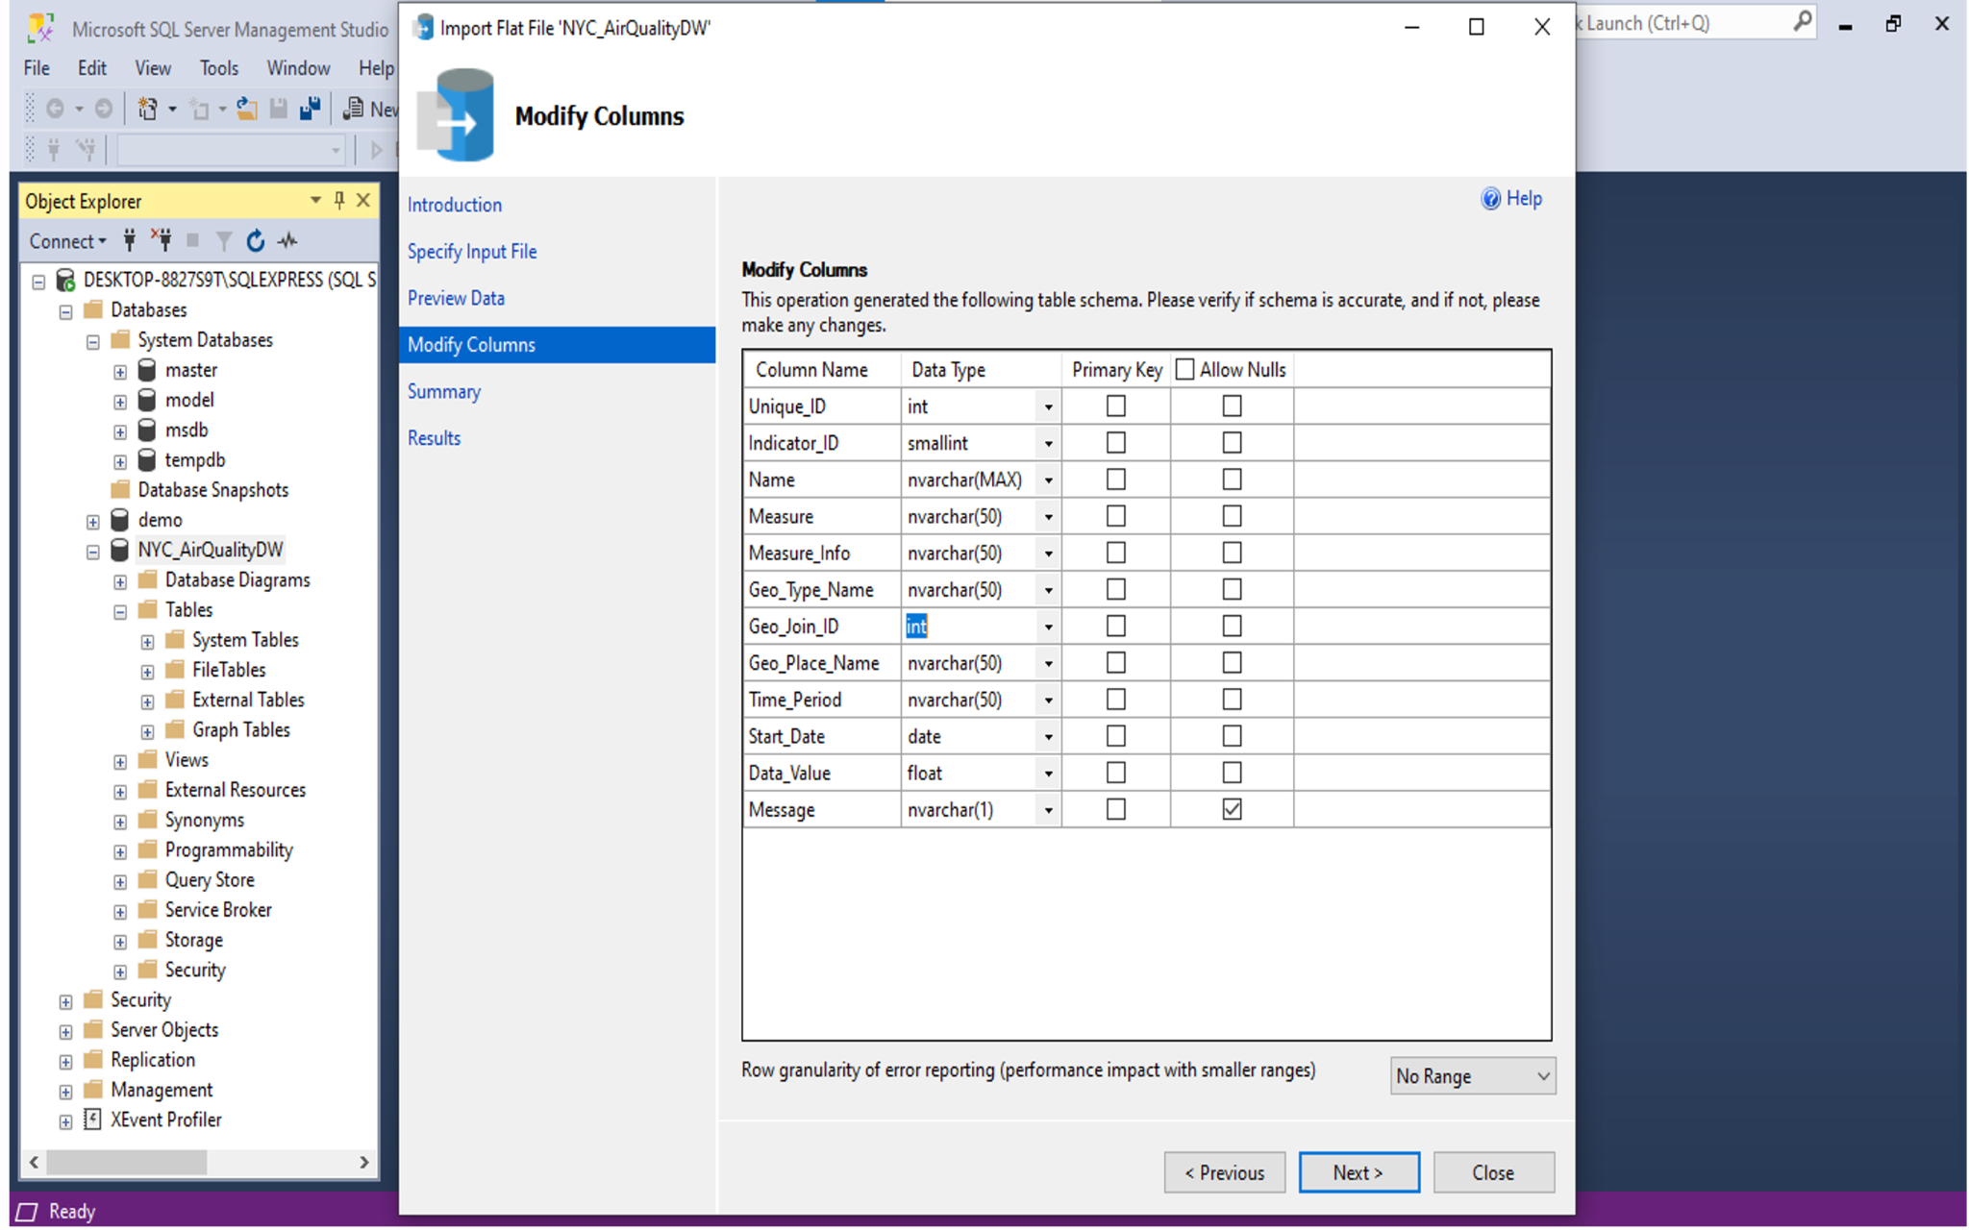

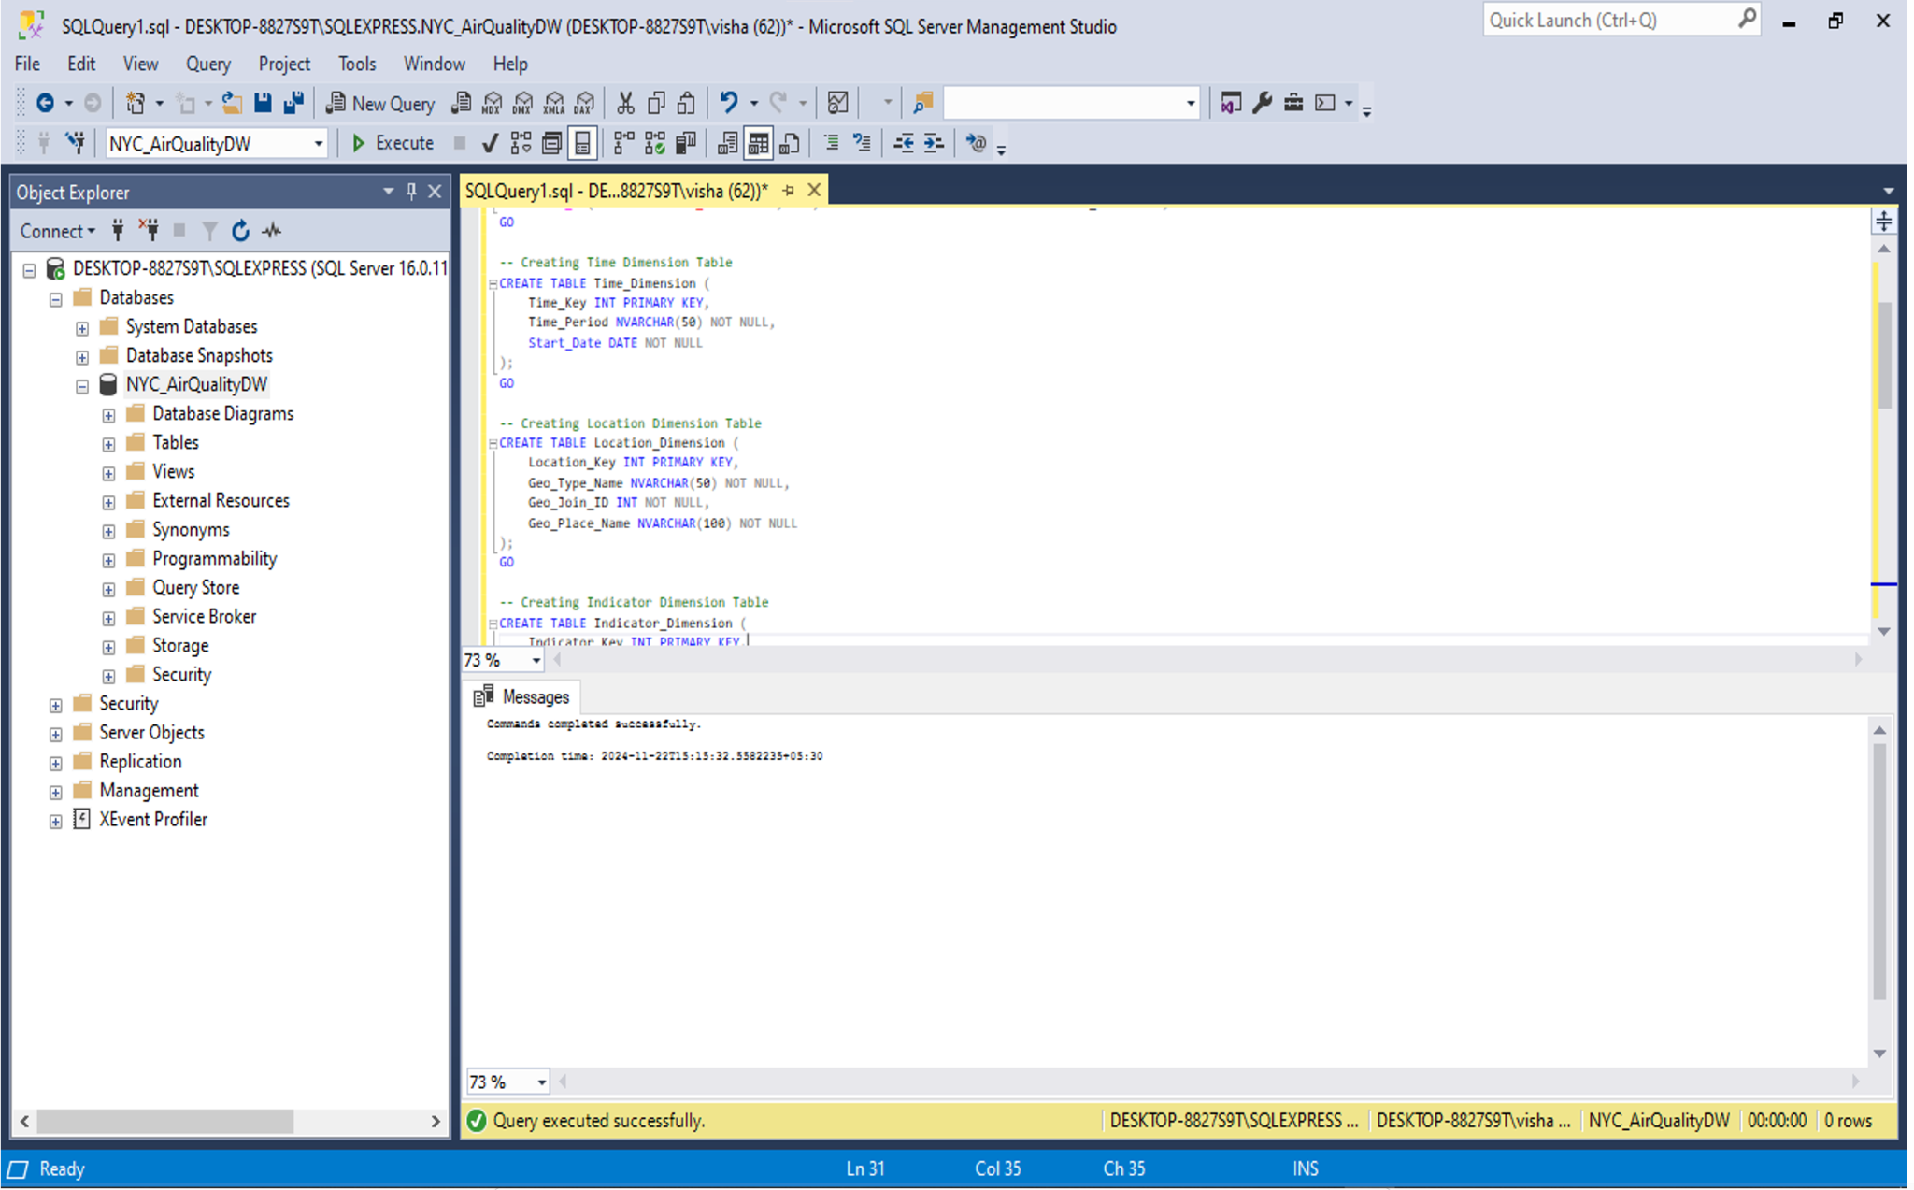

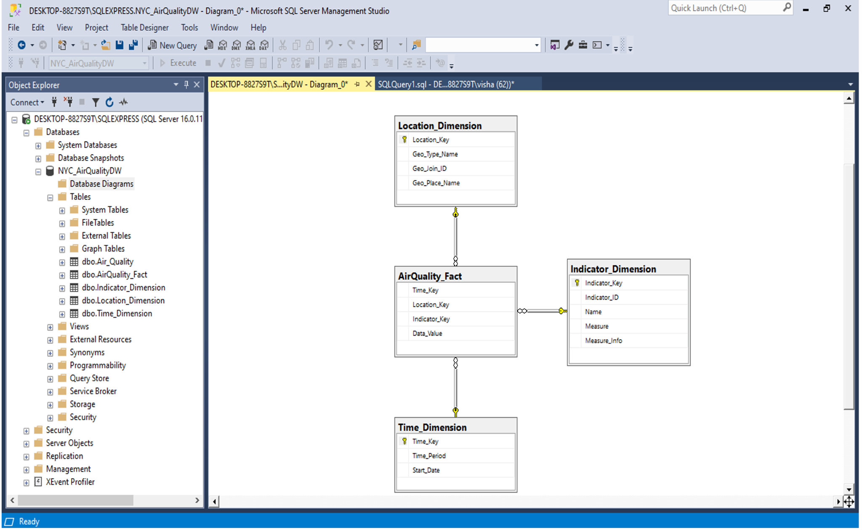

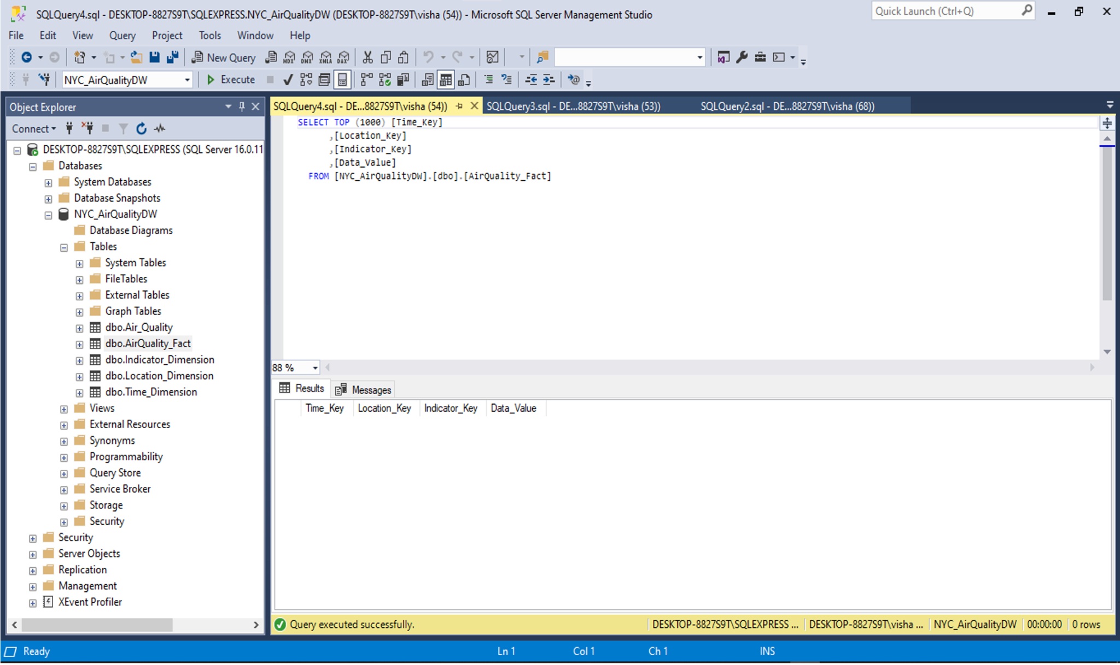

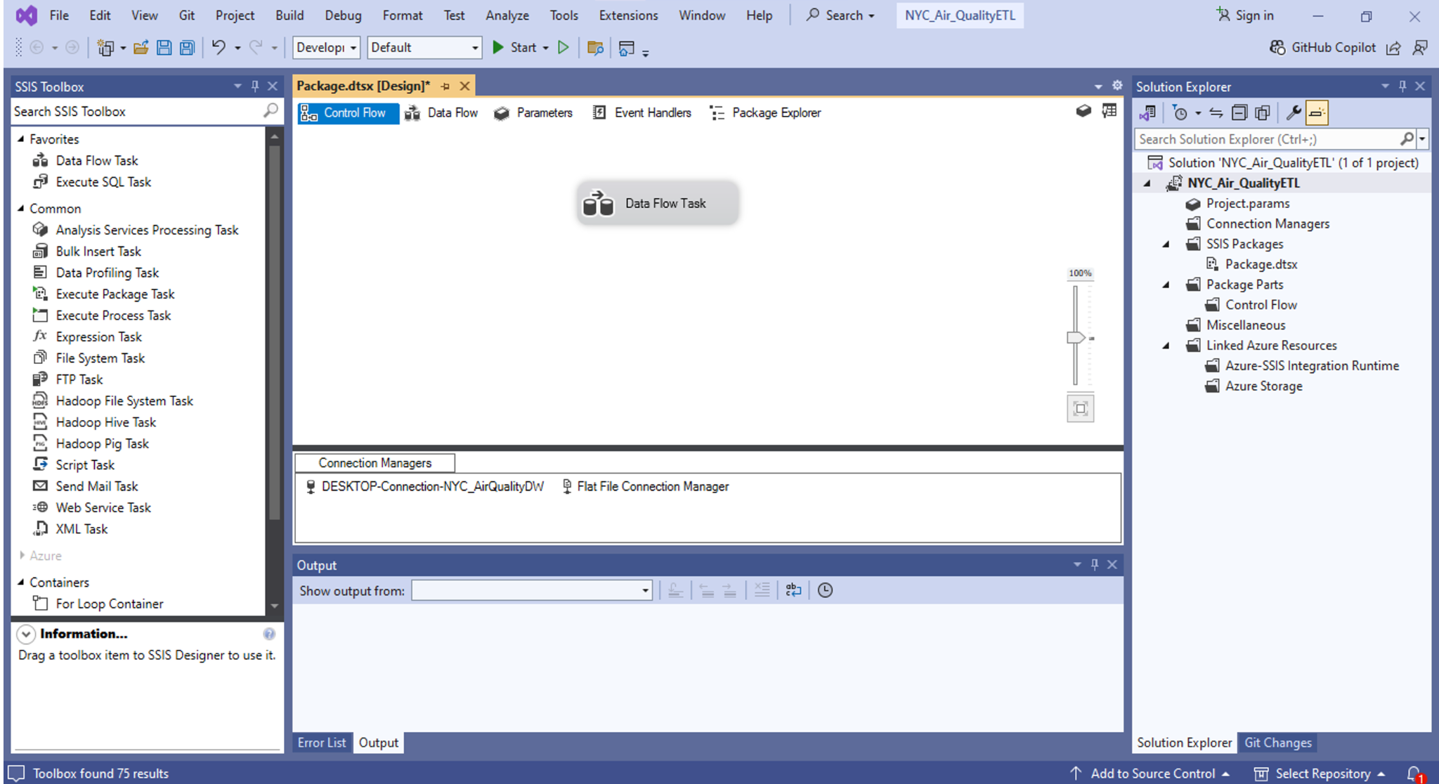

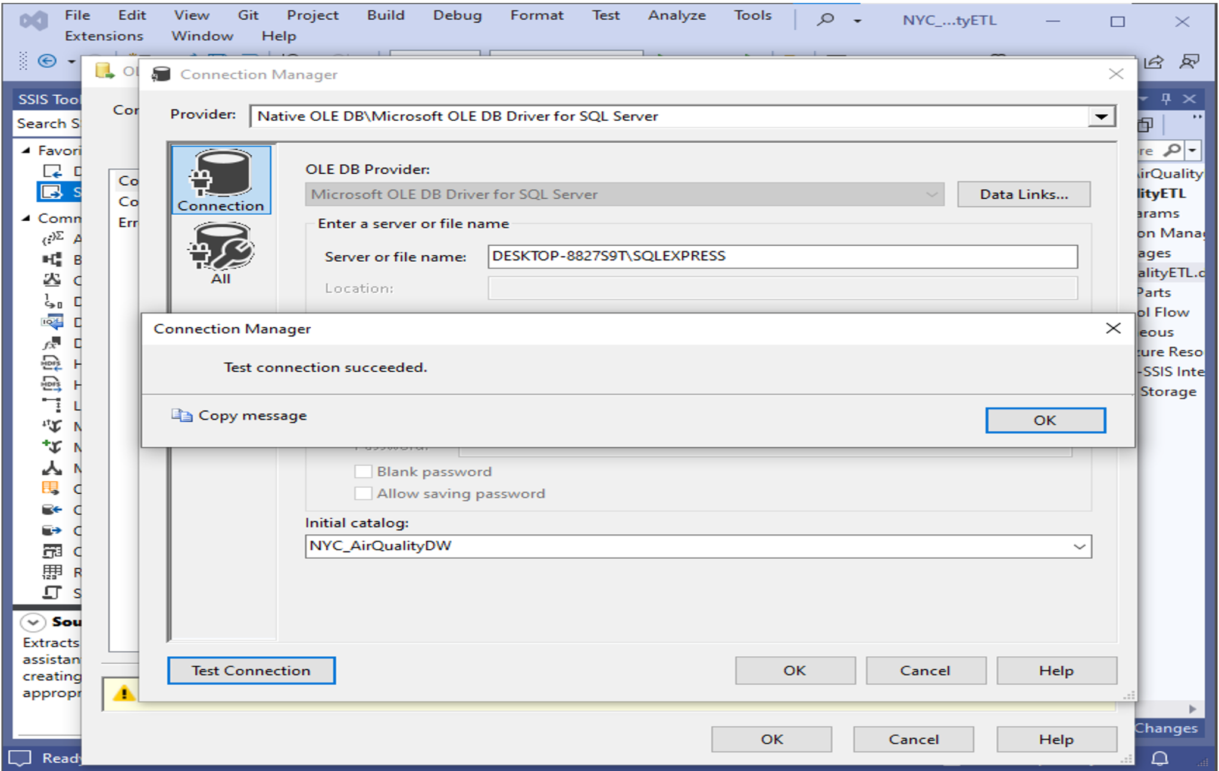

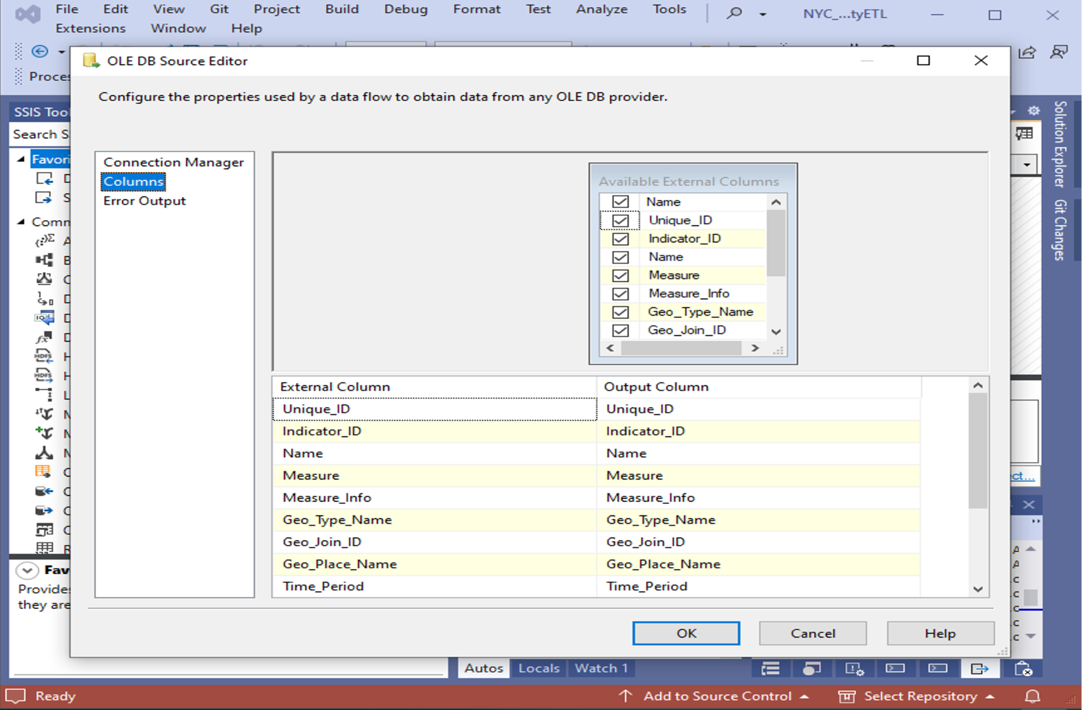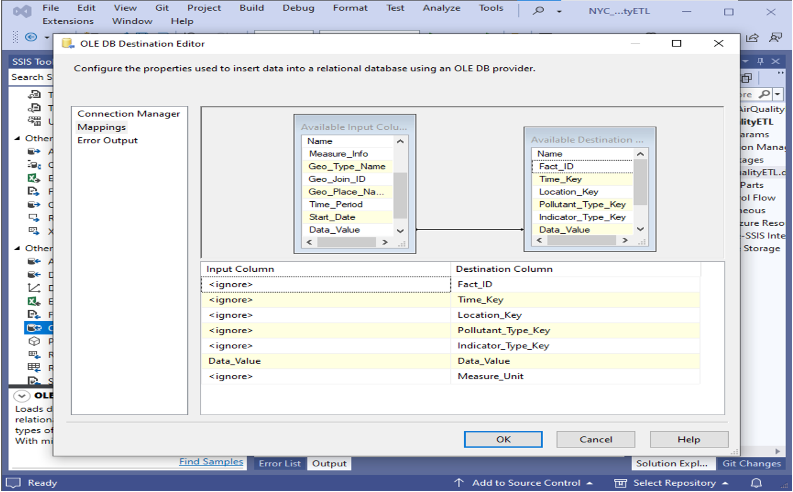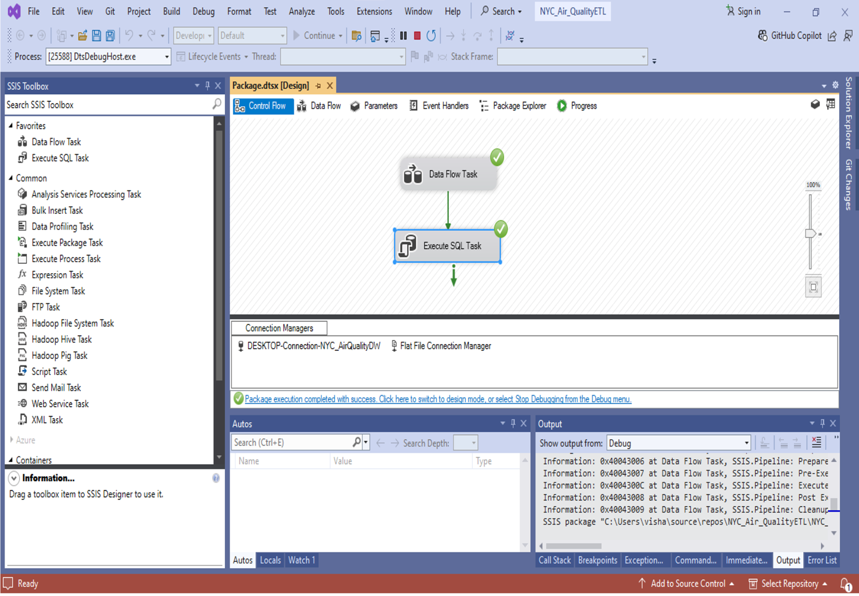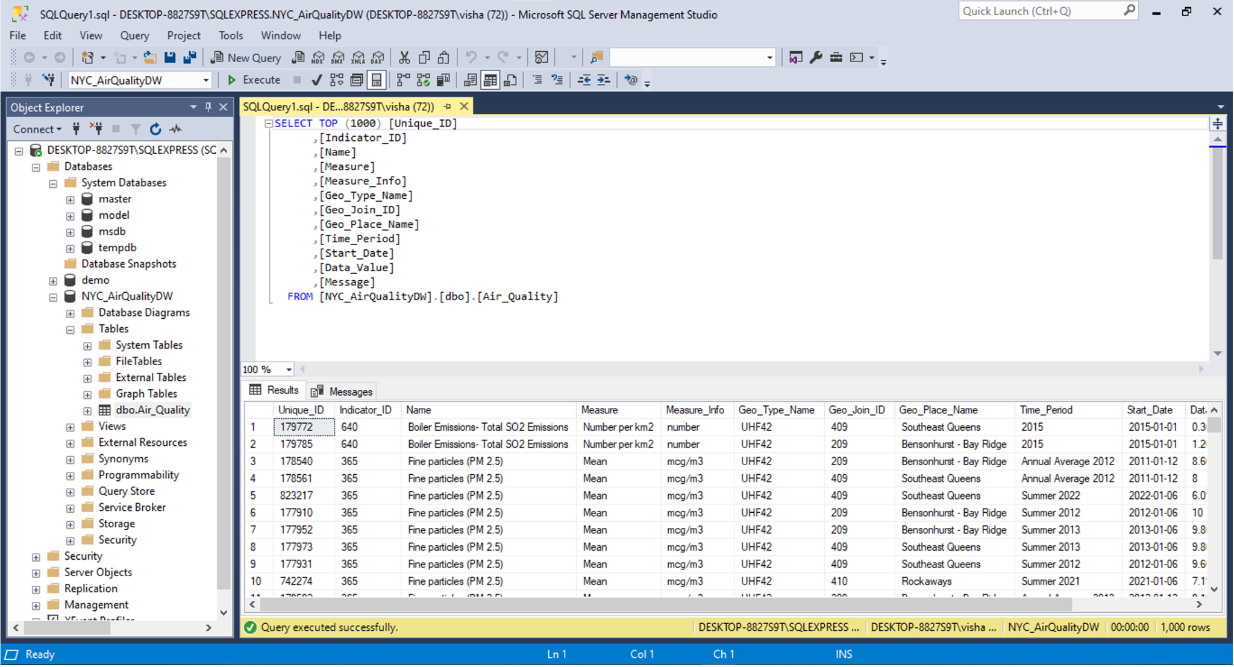

**Validation and Testing**

Validation queries were written to:

* Rows ers should verify that the same number of rows exists between the source and target systems
* The system should check the integrity of foreign key relationships between its tables.
* Perform an examination for absent or peculiar data values after data load concludes

**5. Reports and Visualizations**

**Overview**

The NYC air quality data warehouse received its actionable insights through visualization and analytical reporting tools based on Tableau and SQL Server Reporting Services (SSRS). The created visual representations help stakeholders examine data trends through time-based and location-based and indicator-based analyses.

The monitoring reports combine pollutant measurement data with details of healthcare issues linked to polluted air environments. By studying problems through multiple perspectives this approach delivers full knowledge about environmental as well as social outcomes.

**Tableau Visualizations**

Fourth the key visualizations were improved across Tableau platforms and will further optimize data analysis.

The following four major Tableau visualizations were developed:

1. **Daily Pollutant Trends by Neighborhood.**

* **What it is:** A line chart showing air quality index, or AQI, data daily in various New York City neighborhoods from 2005 to 2021. The colored lines show pollution levels in each district over time.
* **Takeaway:** Pollution levels saw a dramatic seasonal increase each winter but had declined slowly since about 2010.

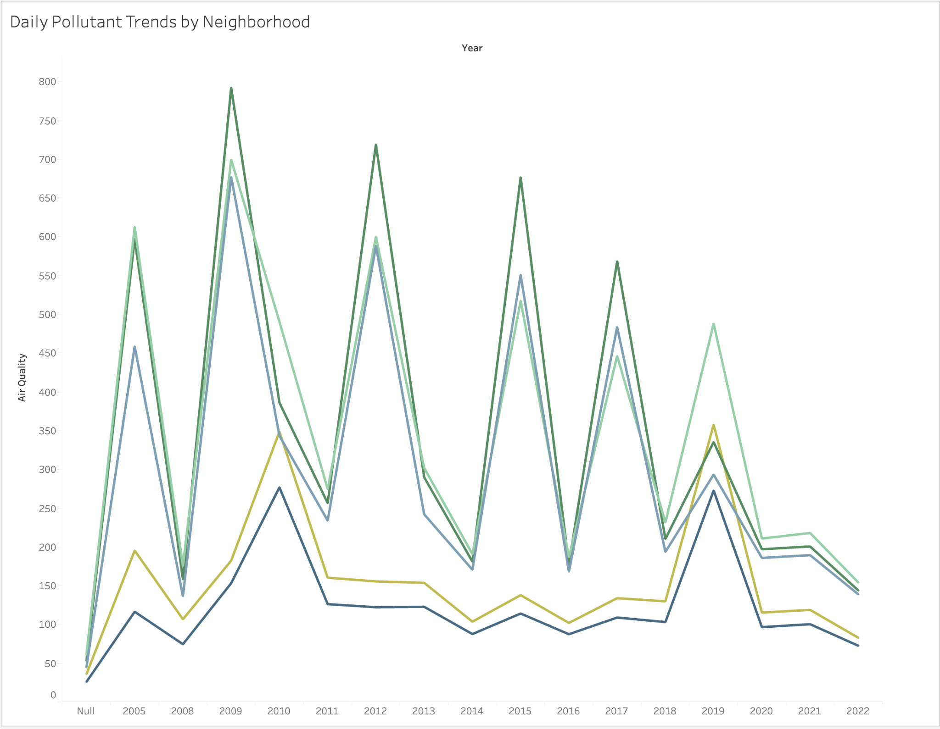

1. **Yearly Average Pollutant Levels**

* Bar chart comparing the average annual number of unique pollution events, in many ways signaling improved air quality over time.
* **Bottom line:** Since 2005, pollution counts have decreased, indicating that awareness of and policies around environmental health are having an impact.

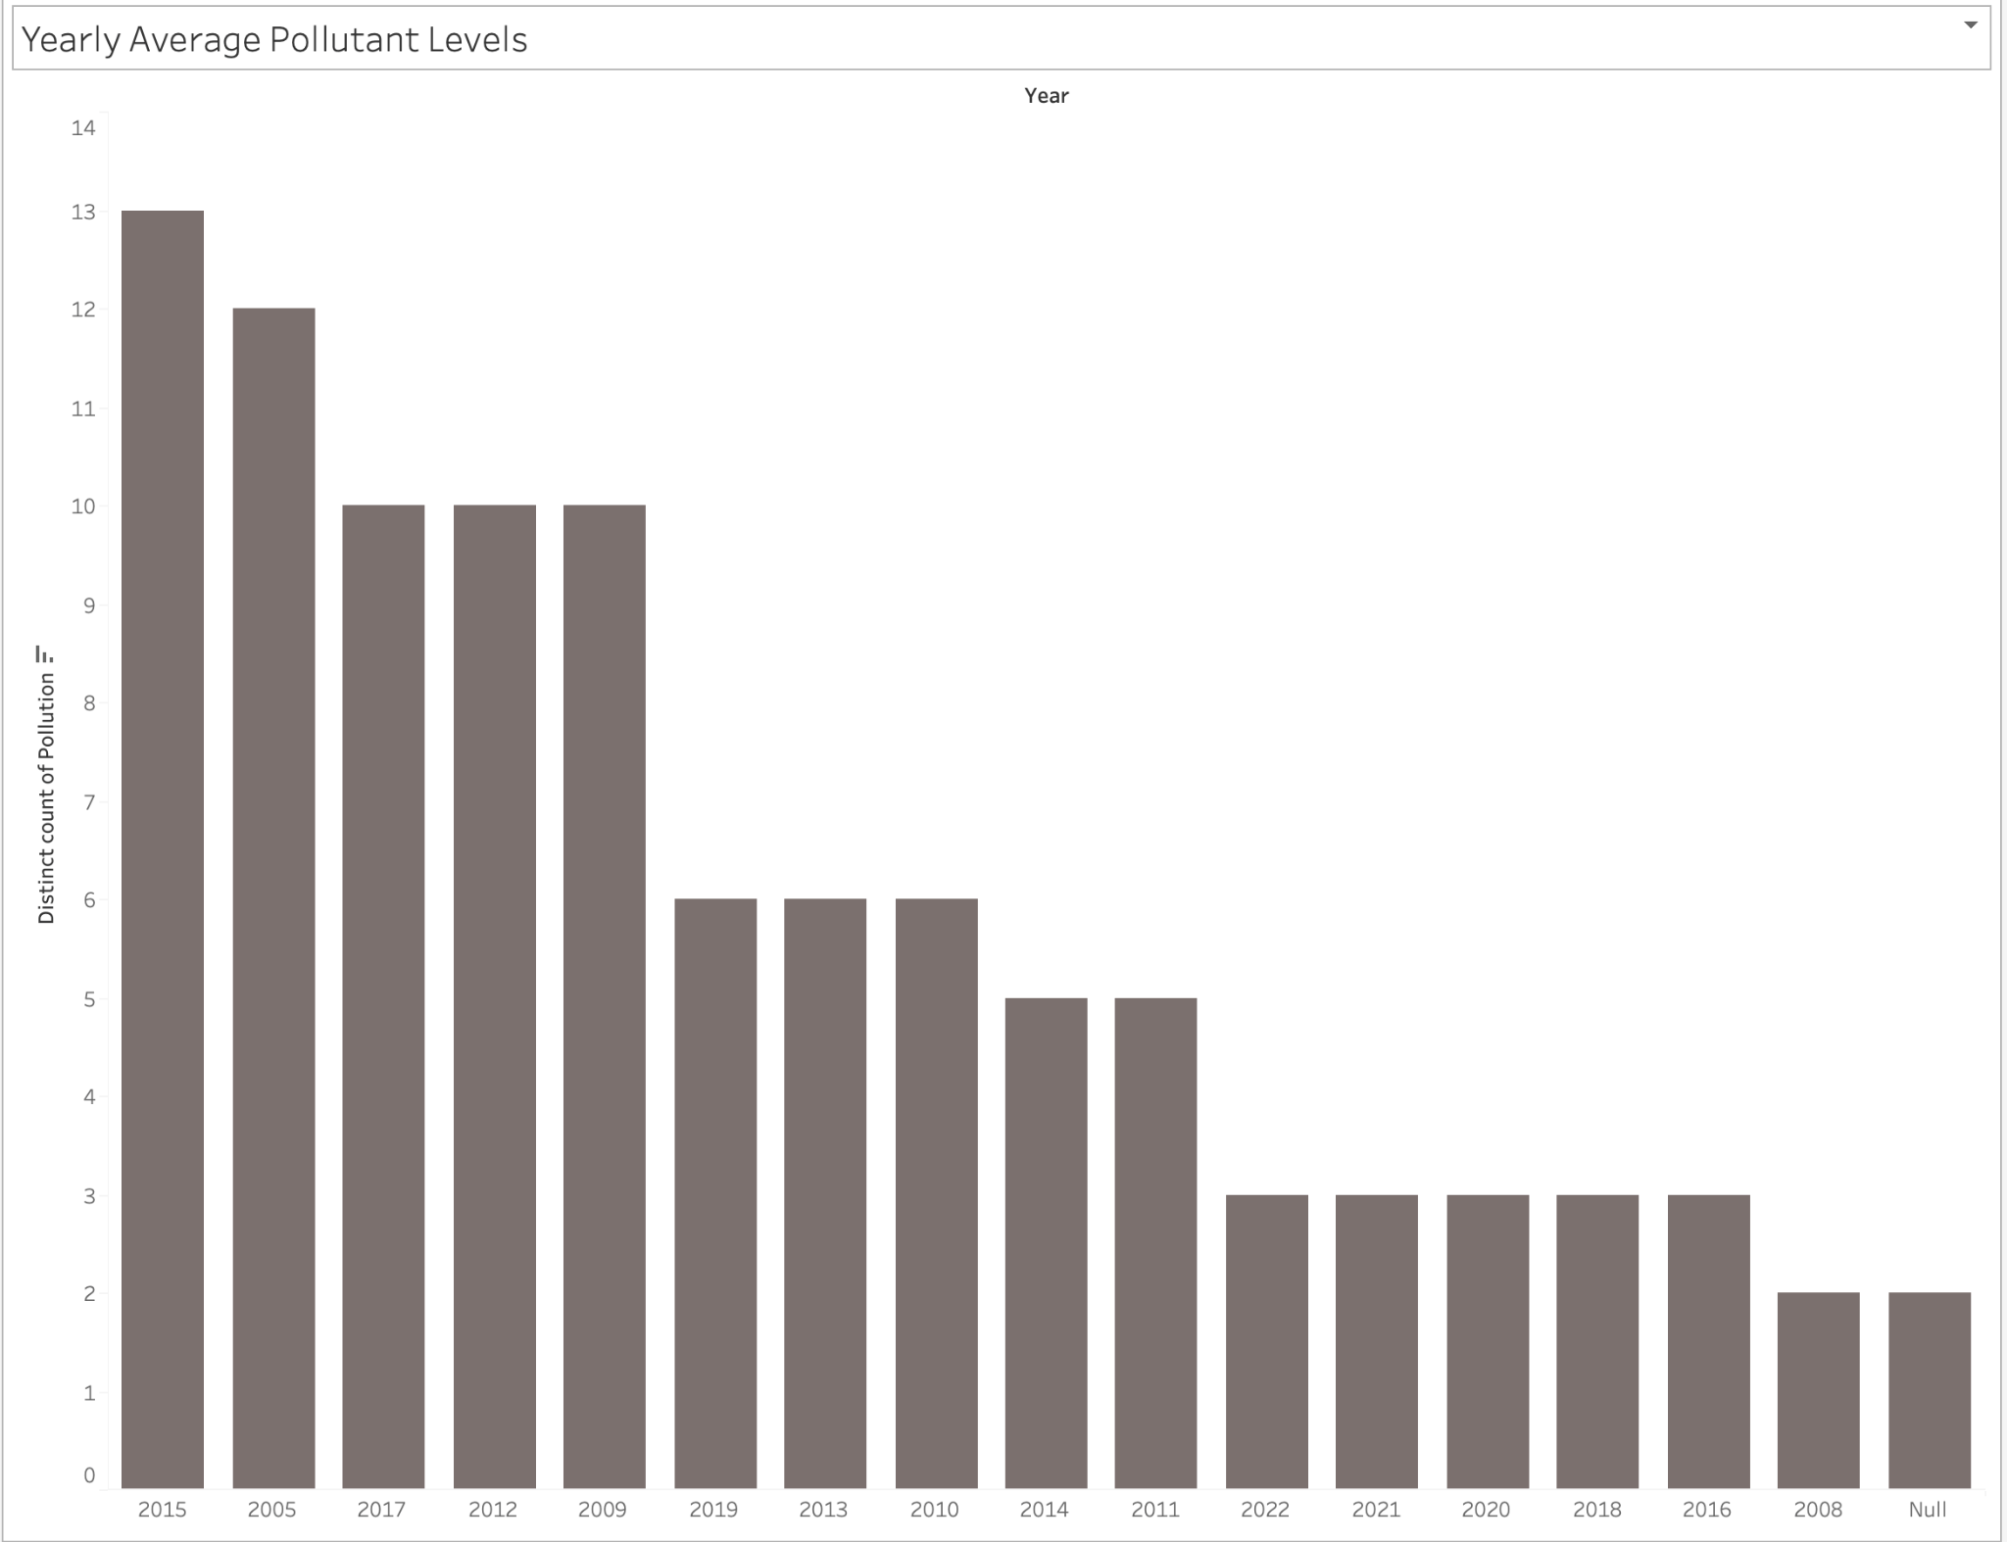

1. **Seasonal Pollution Comparison**

* **Description:** A multi-year set of group bars showing how many pollutants were counted in each season—Fall, Spring, Summer, Winter—to reveal the seasonality of air quality.
* **Bottom line:** Wintertime brings the highest levels of pollutants, likely because of heating sources and less air movement.

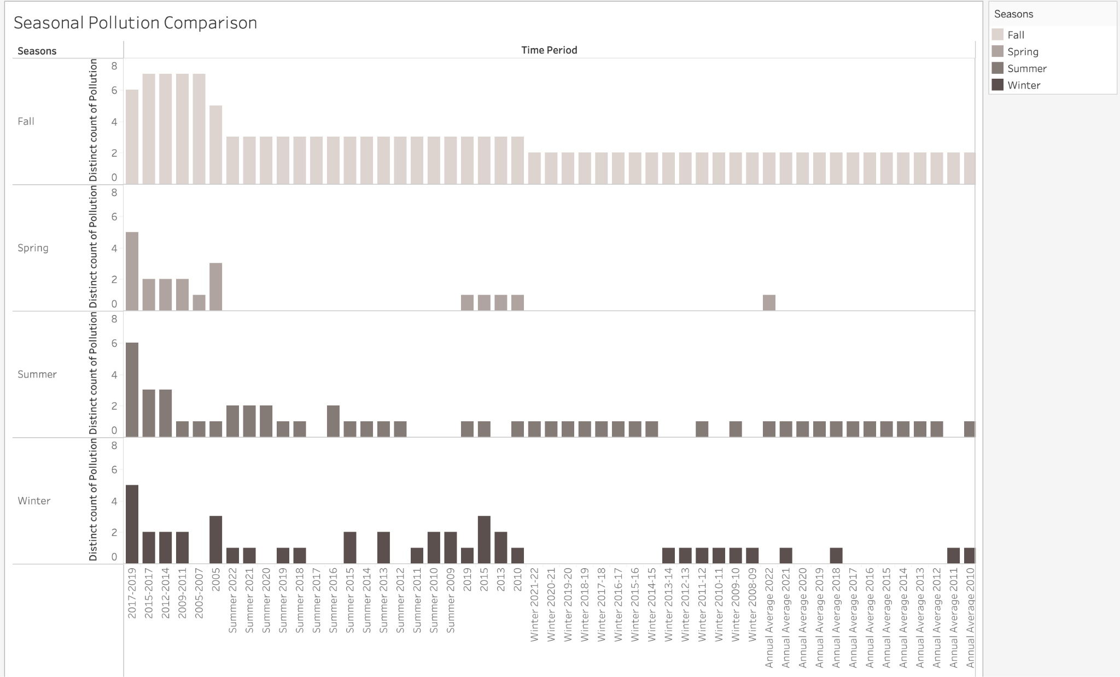

1. **Adverse Health Effects vs. Air Quality**

* **Description:**A bubble chart correlating adverse health outcomes (e.g., asthma emergency visits, respiratory hospitalizations, deaths) with pollution exposure levels.
* **Key Insight:**PM2.5 and O₃ pollution are strongly linked to spikes in asthma emergencies and cardiovascular issues, emphasizing the critical impact of air quality on public health.

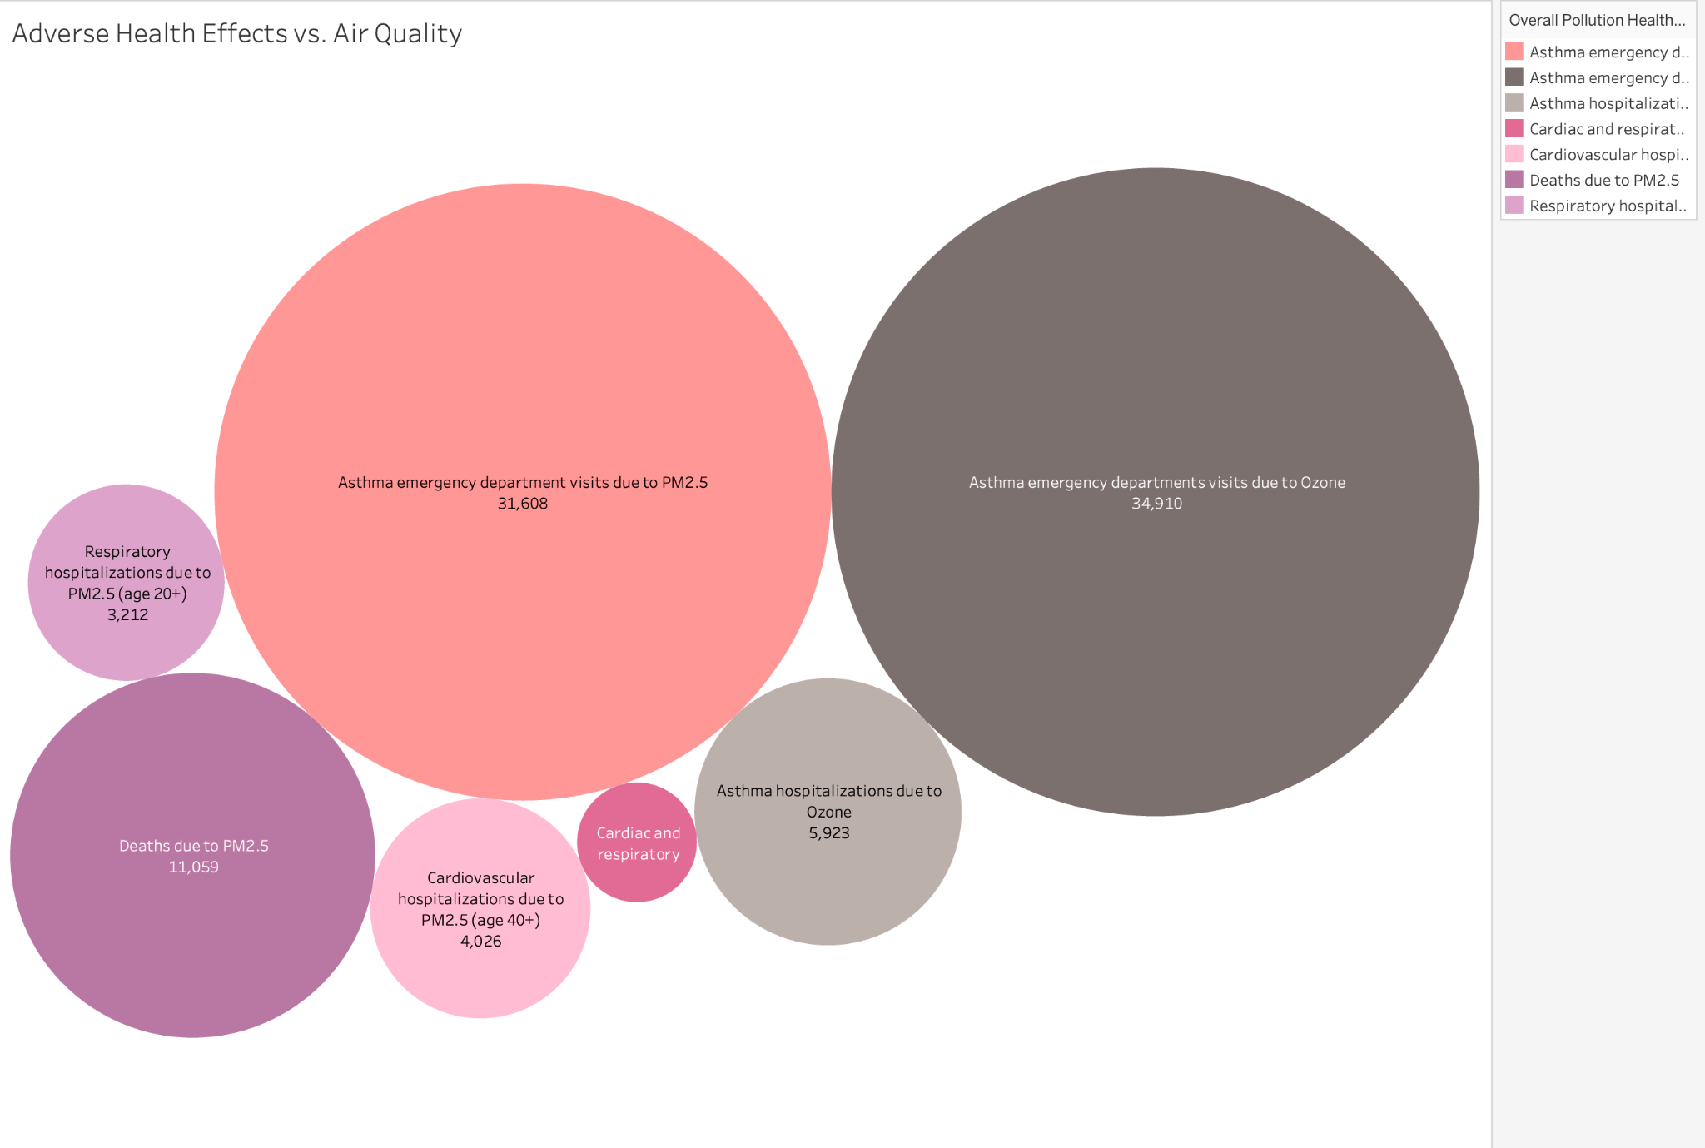

**SSRS Reports**

Additional to Tableau visualizations SSRS reports were developed with four main sections that included:

* Daily pollutant trends by neighborhood.
* Yearly average pollutant levels.
* Seasonal pollution comparison.
* People experience adverse public health effects as a result of air quality modifications.

The SSRS system developed comprehensive tabular documents which official divisions transmitted to both public health departments as well as environmental agencies.

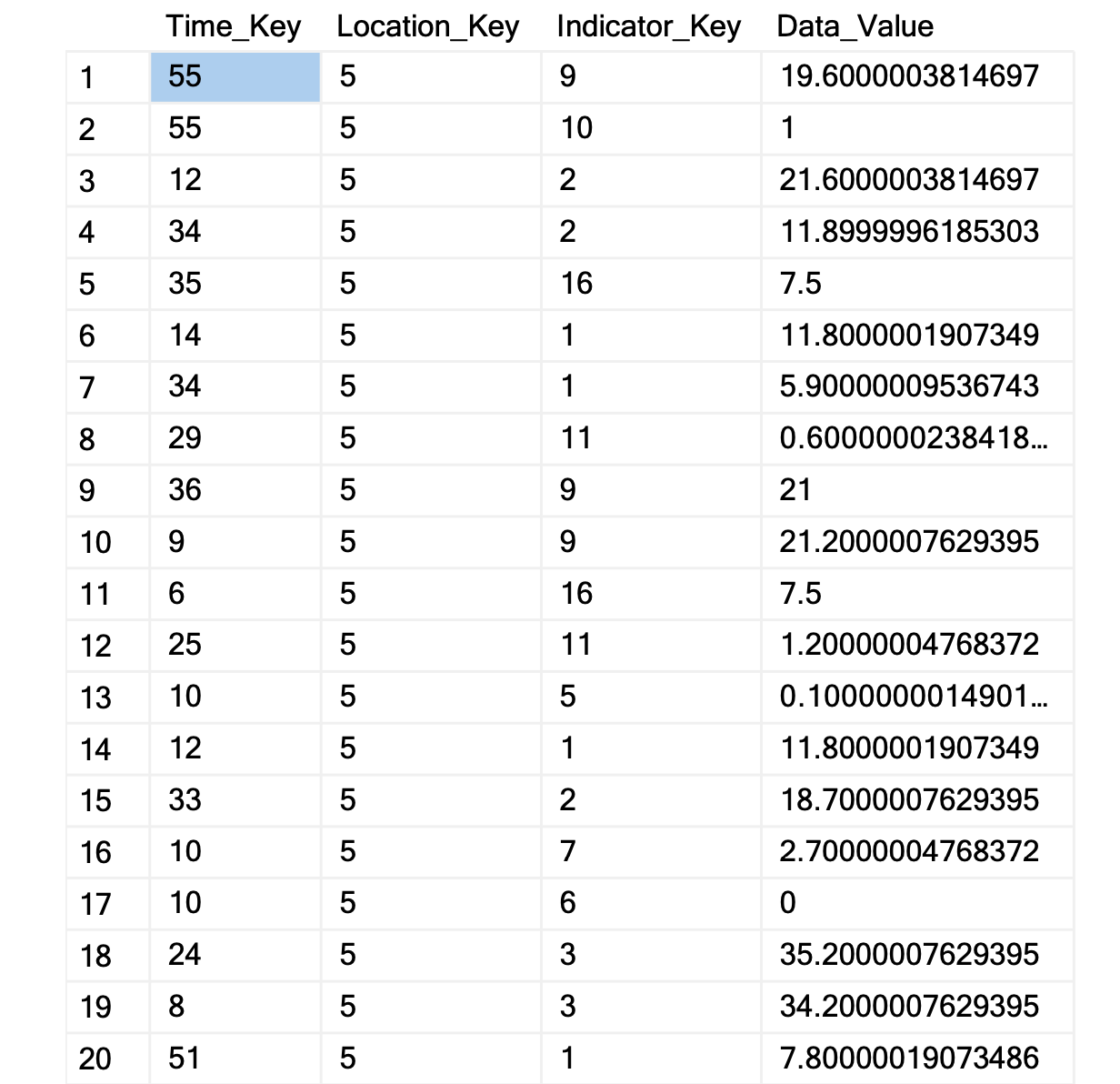

Report_Indication_facts

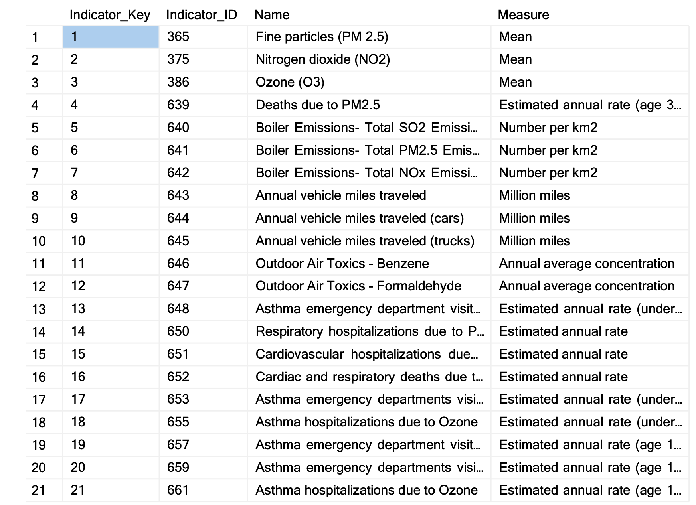

Report Indicator_Type_Dimension

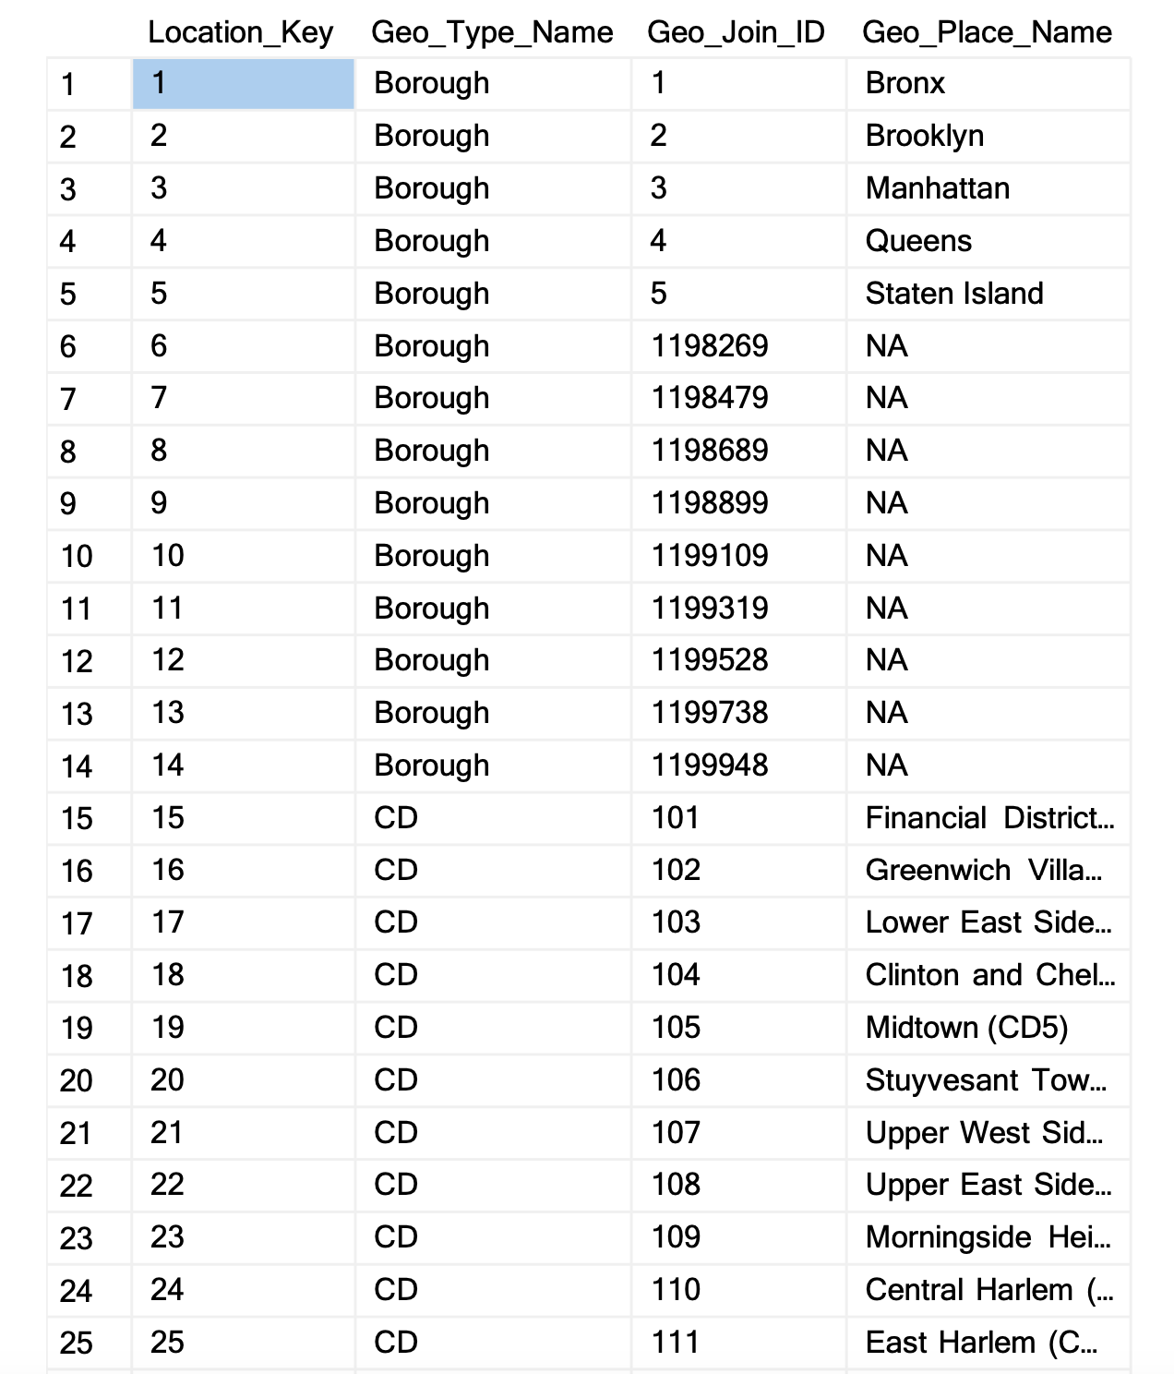

Report Location_Dimension

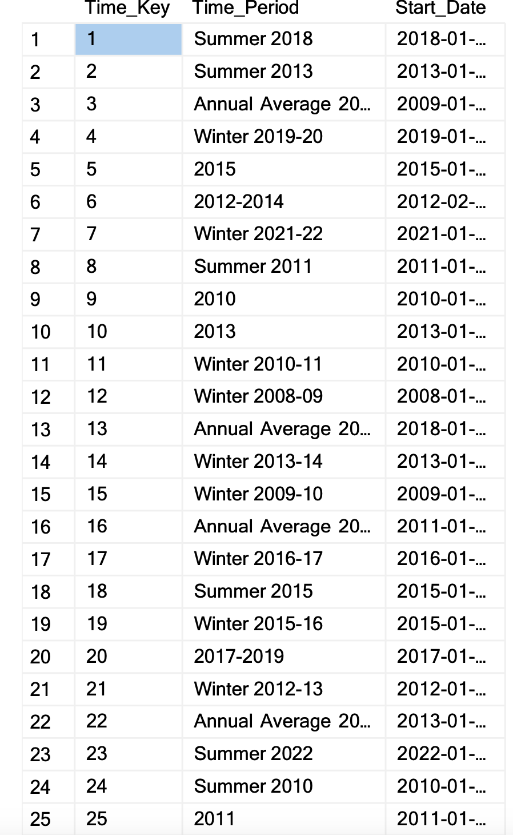

Report Time_Dimension

**Dashboard Integration**

To improve access to, and interaction with, the air quality data warehouse, all Tableau visualizations have been combined into a single interactive dashboard. Out of this came an interactive dashboard for stakeholders to view, in a simple and centralized way, the data that had been analyzed.

**Key Features**

**Filtering Capabilities:**

They can filter by county, by season or year, and by kinds of pollutants, like PM2.5 or NO₂ or O₃.

**Detail Functionality:**

By location and time period, the dashboard allows for more granular datamining to spot pollution hot spots.

**Export Options:**

Users can export filtered views and visual summaries to support reporting and documentation requirements in PDF or image file formats.

**Business Impact**

* It’s designed as a self-serve analytic tool for policymakers, environmental scientists and the public to mine the data without having to navigate the database.
* It helps demystify models of pollution and health impact for data-driven decision making.
* By allowing a spatial view of time series health correlation data on one screen, dashboards give stakeholders rich insight with little effort.

**6: Database Comparison: Relational vs. Graph Databases**

**Overview**

The project involved a comparative study of two different database technologies: relational databases (SQL Server) and graph databases (Neo4j). The goal was to evaluate the efficiency, performance, and flexibility of each approach for storing and querying complex data sets using seven sample queries applied to both systems.

In a relational database, information is stored in tables with fixed schemas and primary and foreign key constraints; graph databases, by contrast, organize data into nodes, which are entities, and relationships, which are the connections between entities; this more closely mirrors how it’s tracked in the real world and is a nimble and intuitive way to approach data in relationship to other data.

**Implementation Approach**

The relational database model linked Product to ProductCategory to ProductSubCategory to Vendor to ProductVendor by using SQL queries based on foreign key relationships. The same entities within Neo4j existed as nodes that formed connections through relationships including "BELONGS_TO_CATEGORY" and "SUPPLIES". The Neo4j import process used CSV file loading to create nodes while establishing relationships which followed the original relational design.

**SQL vs CQL Queries and Results**

The project required implementation of seven queries against both SQL Server using T-SQL and Neo4j using Cypher Query Language - CQL.

Neo4j Graph Relationships with its SQL equivalent using Adventure works dataset

Overall graph of dataset with nodes and relationships consisting of five tables viz: Product, ProductCategory, ProductSubcategory, Vendor, and ProductVendor, and sets of Relationship types and seven (7) sample relationships between two or more of them for both Neo4j and SQL.

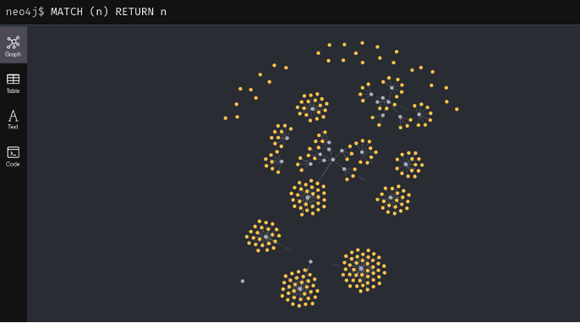

1. A Relationship between Subcategories and the (broader) Categories they belong to.

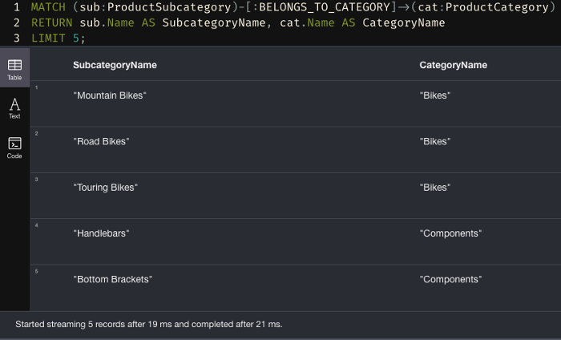

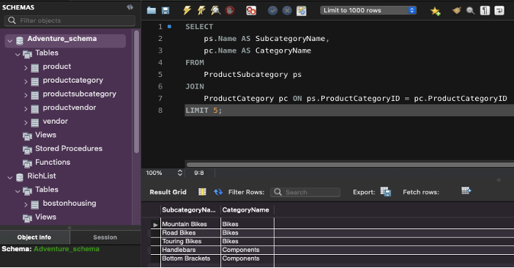

2. A relationship between Product, Sales starting and end dates, and the subcategories they belong to.

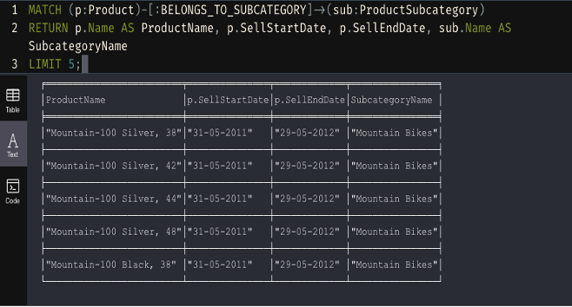

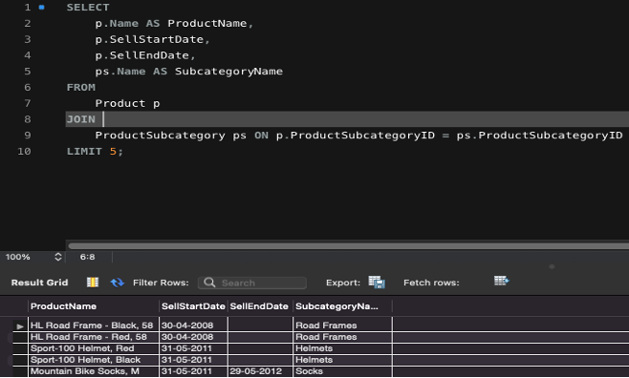

3. A relationship between some Products and the Subcategories they belong to.

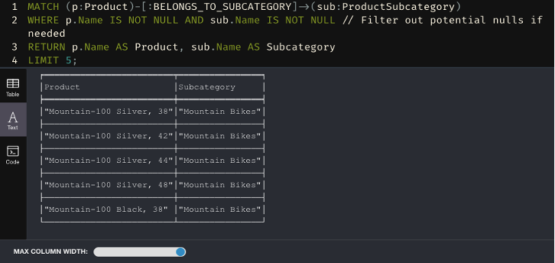

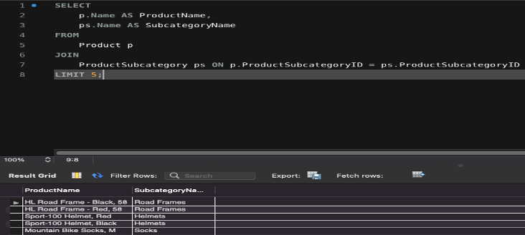

4. Relationship with Vendor supplying Product with product Price

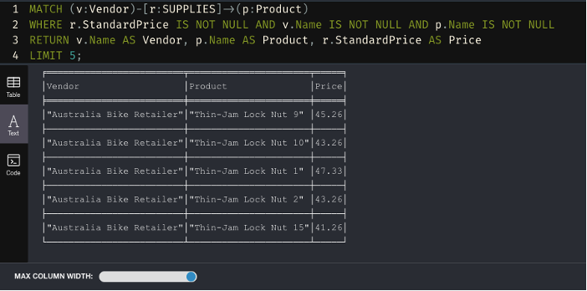

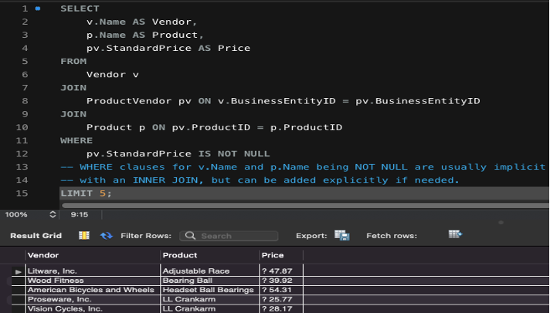

5. A Relationship between Vendors, the products they supply (by name) and the Lead Time

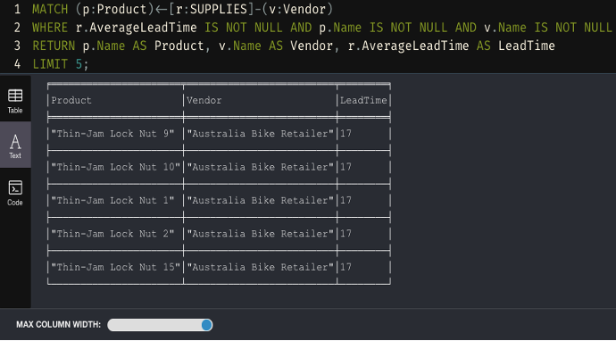

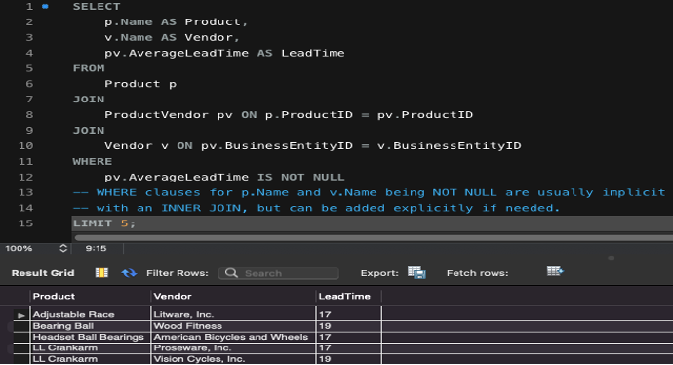

6. Double relationship between Products belonging to a Product-Subcategory which belongs to a Product-Category

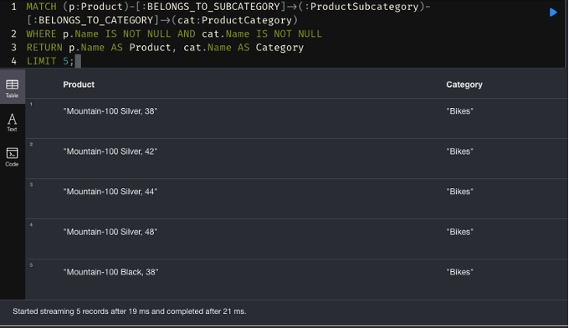

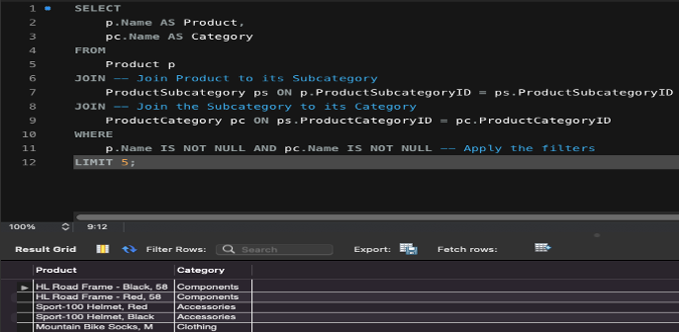

7. A Relationship between Vendors, name of Products they supply, the Prices and the Sub-categories those products belong to.

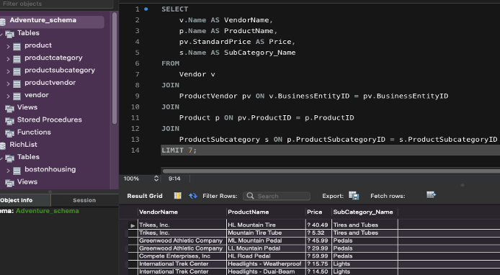

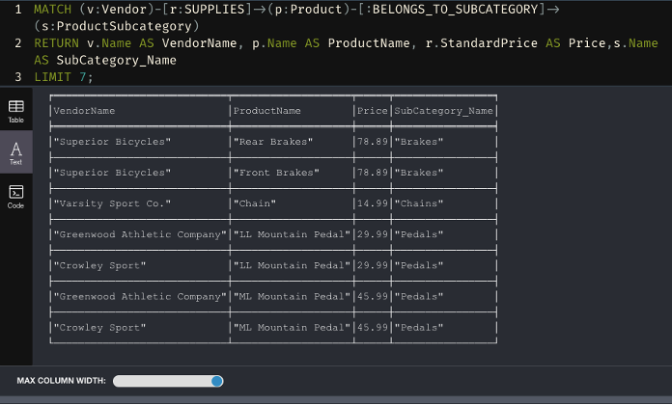

Relationship type 1 [BELONGS_TO_CATEGORY]: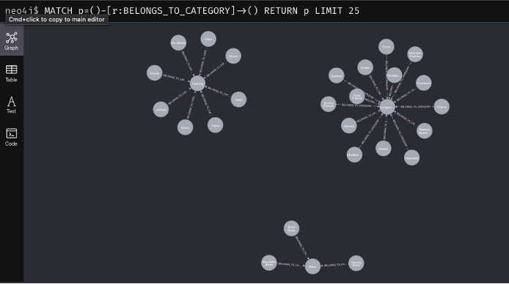

Relationship type 2 [BELONGS_TO_SUBCATEGORY]:

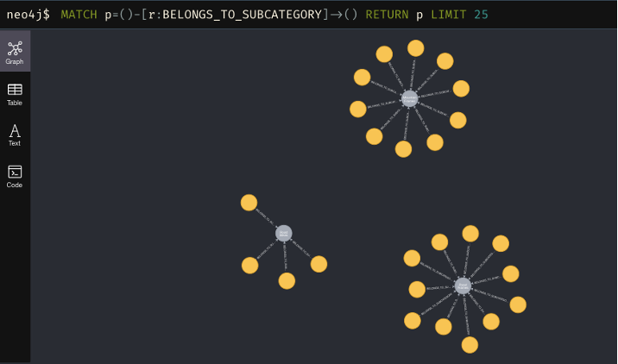

Relationship type 3 [SUPPLIES]: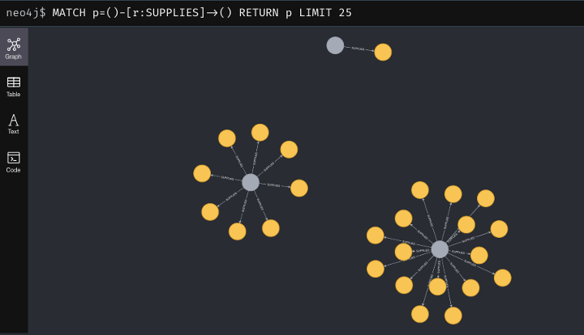

**7. Overall Discussion and Reflection**

**Project Achievements**

Utilizing an effectively structured dimensional data warehouse the NYC Air Quality Analysis project achieved transformation of complex fragmented datasets into useful business information.Different source data enabled us to develop a database based on the star schema design format which facilitated comprehensive analysis of pollution patterns and health results and geographical patterns in New York City.

The ETL process standardized data through cleaning methods which also repaired faulty input and validated complete records within both fact and dimension tables. As part of our work we designed the ETL workflows while performing data quality inspections. With the help of Tableau and SSRS complicated designs became simple to understand, entitle stakeholders such as policymakers and public health employees with interactive insights.

Additionally, the study which is comparative between relational(SQL Server) and Neo4j graph databases shows the adaptability of different storage models based on query complexity and relationship depth.

**Challenges Encountered**

Several challenges were encountered throughout the project:

* Data Inconsistencies and Missing Values: The raw data had missing fields and inconsistent formatting. Robust transformation rules and validation scripts had to be developed to address these issues.
* Schema Normalization and Key Mapping: Designing efficient foreign key relationships without losing analytical flexibility was complex and required multiple iterations.
* Managing High Data Volume: The data warehouse had to manage large datasets spanning multiple contaminants and locations without performance degradation during querying and visualization.

**Skills and Knowledge Gained**

The project strengthened my capabilities to perform technical and analytical work through several key elements.

* The design of star schemas together with fact/dimension table connectivity stands as the fundamental focus of dimensional modeling as well as analytics design concepts.
* Advancement in SQL Scripting and Data Validation includes writing robust scripts for extraction and transformation and testing​Single-Handed Project Execution.​Individual Contribution….

ETL Automation with SSIS: Building robust, fault-tolerant data pipelines.

Comparative Database Analysis: Understanding the practical differences between relational and graph databases for different types of business queries.

# 

# 

# 

# 

# 

# 

# **References**

chugugrace (2024) *SSIS How to Create an ETL Package - SQL Server Integration Services (SSIS)*. Microsoft.com. Available at: <https://learn.microsoft.com/en-us/sql/integration-services/ssis-how-to-create-an-etl-package?view=sql-server-ver16> (Accessed: 10 April 2025).

erinstellato-ms (2024) *Download SQL Server Management Studio (SSMS)*. Microsoft.com. Available at: <https://learn.microsoft.com/en-us/sql/ssms/download-sql-server-management-studio-ssms?view=sql-server-ver16>(Accessed: 10 April 2025).

GeeksforGeeks (2018) *Star Schema in Data Warehouse Modeling*. Available at: <https://www.geeksforgeeks.org/star-schema-in-data-warehouse-modeling/> (Accessed: 10 April 2025).

Murphy, S.A. (2013) *Data Visualization and Rapid Analytics: Applying Tableau Desktop to Support Library Decision-Making*. Journal of Web Librarianship, 7(4), pp.465–476. Available at: <https://doi.org/10.1080/19322909.2013.825148> (Accessed: 10 April 2025).

Neo4j Documentation (2024) *Neo4j Graph Data Platform*. Available at: https://neo4j.com/docs/ (Accessed: 10 April 2025).

Tableau (2023) *Tableau: Business Intelligence and Analytics Software*. Available at: <https://www.tableau.com/>(Accessed: 10 April 2025).

NYC Open Data (2025) *NYC Environmental & Health Data*. Available at: https://opendata.cityofnewyork.us/(Accessed: 10 April 2025).

Environmental Protection Agency (EPA) (2025) *Air Quality Data*. Available at: <https://www.epa.gov/outdoor-air-quality-data> (Accessed: 10 April 2025).